**TURNAROUND TIME ANALYSIS**

INTRODUCTION:

The Aircraft Turnaround has been identified to be crucial for airline schedule adherence, for high customer satisfaction, and economic productivity. A number of ground operations have to be processed, in sequence, to service the aircraft. These comprise 1.) Placing of chocks (rubber blocks that prevent aircraft from moving) in front of the aircraft's wheels after it comes to full stop 2.) Unloading of passengers and baggage 3.) Post-flight administration 4.) Pre-flight administration 5.) Catering replenishment 6.) Aircraft cleaning 7.) Security checks 8.) Loading of passengers and baggage, and 9.) Removal of chocks for departure. Cleaners, ground handlers and engineers execute these processes and shall best coordinate their activities to provide a seamless aircraft turnaround.

All these processes are being scheduled against the Scheduled Time of Arrival (STA) and - by assuming a dedicated taxi-in time - scheduled against the “on block (chock)” times at the assigned aircraft stand, either remote or at the terminal building according to the airport’s stand allocation scheme.[REF: [Microsoft Word - Turn_Aorund_Performance_ATM2009_1.3_ms260109.doc (atmseminar.org)](http://www.atmseminar.org/seminarContent/seminar8/papers/p_153_AO.pdf)]

The dataset for this particular analysis is simulated from various sources and has 30 records which includes all the critical paths causing the major delay for an aircraft. [sampledata turnaround time analysis.csv]

AIM OF THE ANALYSIS

The major goal of the analysis is to find out whether the processes during turnaround time are causing major delays for the aircraft, and if they do what are the major processes causing the majority of the delay.

KEY FACTORS TO CONSIDER BEFORE THE ANALYSIS

The dataset which is simulated has processes which are assumed to take majority of the delay time. These processes are called as critical paths which include

1. Deboarding of passengers
2. Re-fueling
3. Cleaning
4. Jet bridge
5. Boarding of passengers
6. Restocking of food

Hypothesis – to test whether the critical paths are causing majority of the delay.

PROCESS AND ANALYSIS

Python software is used for the analysis and the notebook used for the coding is GOOGLE COLABORATION. The libraries used for the analysis are

1. Pandas - They help in retrieving the data in the csv format, and the dataframes helps us to do all kinds of operations with the data.
2. Numpy - Logical and numerical calculations are carried out with the help of this library.
3. Matplotlib – This library helps us to visualize the dataset in graphical format.
4. Datetime – The numbers in the dataset are not read as time when retrieved in python so the dataset ahs to be converted to datetime datatype.
5. Timedelta – Any logic which has to be used for the datetime datatype will have to undergo this library.

The first step in this analysis is to find out what is the turnaround time for each aircraft in the given dataset. To find out this, the time difference is taken between the ‘TAKE OFF’ and the ‘EXPECTED ARRIVAL’ columns in the dataset.

FIG1 shows the scheduled turnaround time which is the obtained by the above mathematical operation.

The mean time for all the aircrafts for the turnaround process is 40 minutes. This implies that we can consider 40 minutes to be the ideal time for the entire turnaround process.

To obtain a more accurate result we have calculated the frequency of counts for the scheduled arrival and all the critical paths. The table and the graph for scheduled turnaround time is shown in FIG2 and FIG3.

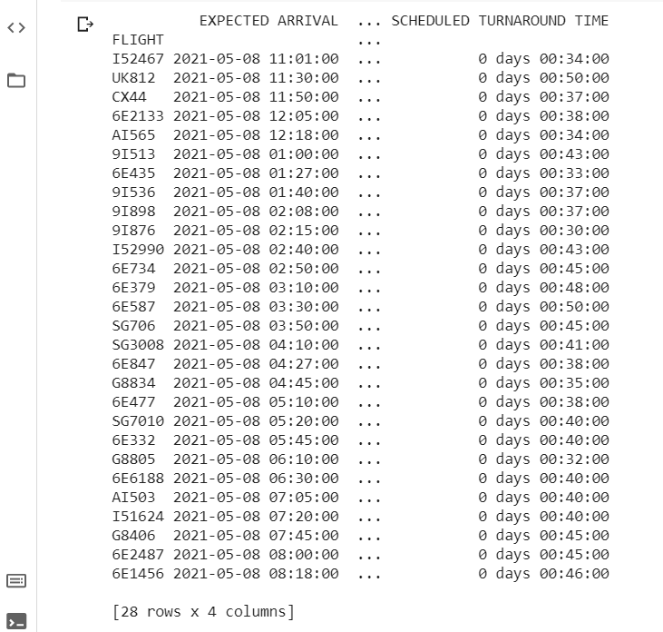FIG1.

FIG2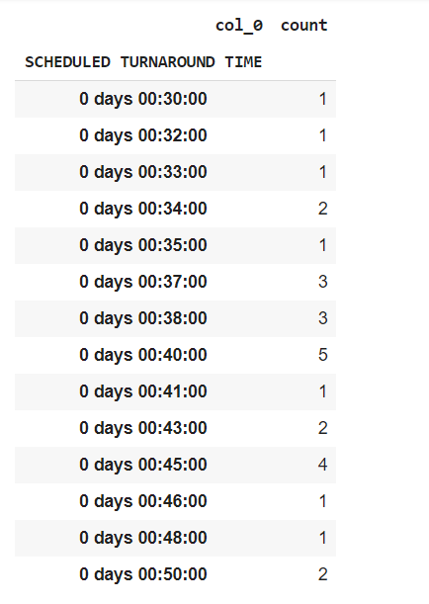

FIG3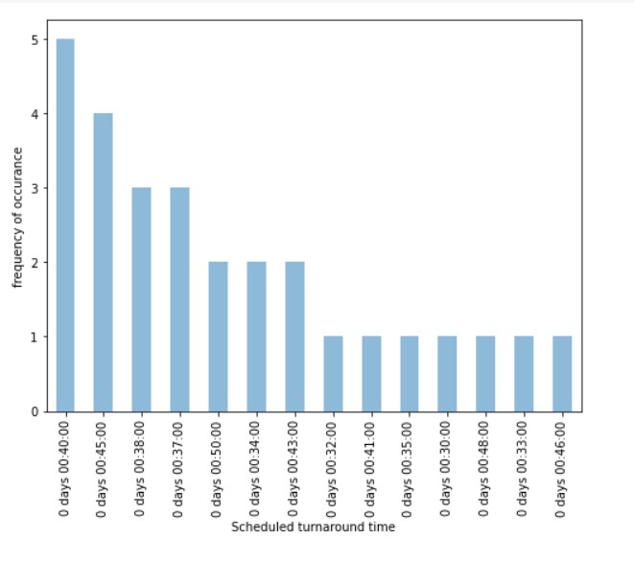

Insight 1: 5 out of 28 aircrafts took 40 minutes 4 out of 28 aircrafts took 45 minutes and 6 aircrafts took more than 37 minutes for the turnaround process. 14 out of 28 aircrafts, i.e 50% of the aircrafts took more than 40 minutes but less than 50 minutes, 2 aircrafts took 50 minutes i.e 7%. The ideal time for the turnaround process is considered anywhere between 30 to 40 minutes and 12 out of 28 aircrafts i.e 42% of the aircrafts fall under this category.

Critical path 1: Deboarding of passengers

To calculate the time taken for the deboarding process we take the difference between ‘UNLOADING OF PASSENGERS END’ and ‘UNLOADING OF PASSENEGERS START’ columns. The mean time taken for this critical path is 9 minutes, and the graph for the frequency of count is as shown in FIG4.

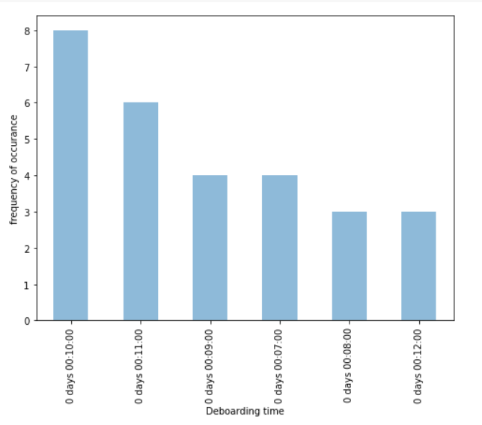FIG4

Insight 2:

8 out of 28 aircrafts took 10 minutes which constitutes 28% of the total dataset, 6 out of 28 aircrafts took 11 minutes to complete the process which is 21% of the dataset, 3 out of 28 aircrafts took 12 minutes which is 9% of the dataset. Only 11 out of 28 took 9 or less than 9 minutes which is 40% of the dataset. So only 40% of the flights are matching the ideal time but if we consider the mean as 10 then we get 21 out of 28 aircrafts to be within the given range which constitutes 75% of the total dataset.

Critical path 2: Refueling process

We take the column difference between ‘REFUEL ENDS’ and ‘REFUEL START’. The mean time for the refueling process is 16 minutes, and the graph for the frequency of count is show in FIG5.

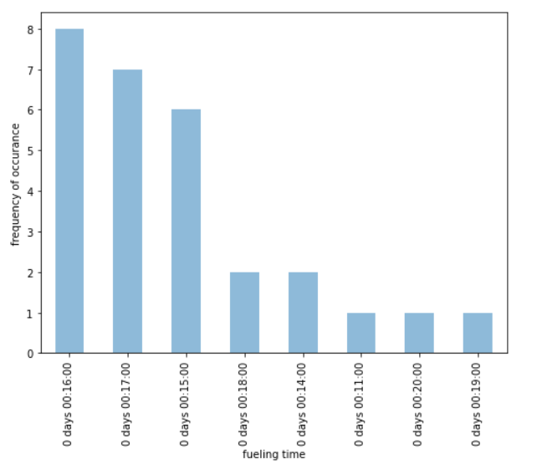FIG5

Insight 3

17 out of 28 aircrafts took 16 or lesser minutes for the completion of the process which constitutes 60% of the total aircrafts. 11 aircrafts have taken more than 16 minutes.

Critical path 3: Cleaning process

Similar to the previous processes the difference between ‘CLEANING ENDS’ and ‘CLEANING STARTS’ columns. The mean time for this process is 7 minutes.

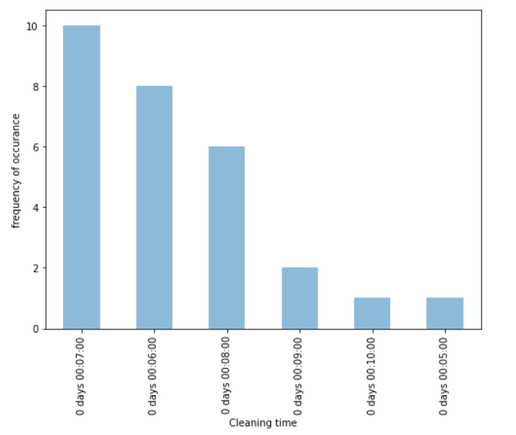FIG6

Insight 4

19 out of 28 aircrafts took 7 or lesser minutes for the completion of the process i.e 67%.

Critical path 4: Jet bridge

Jet bridge is considered to be the most important process in the critical path as the process of removal of the jet bridge depends on many unpredictable factors which might cause the delays for the aircrafts.

After getting the difference of time, the mean value of the jet bridge process is 31 minutes or 32 minutes.

Note: The mean values here are considered for all the aircrafts, including aircrafts which are delayed. This gives us an ideal time to compare the processes which will help us accept the hypothesis. The mean values of the flights which are not delayed cannot be considered as the completion of processes would have taken much lesser time than the ideal time which would not give us an accurate result to accept or reject the hypothesis.

FIG6 shows us the frequency of counts for the jet bridge process.

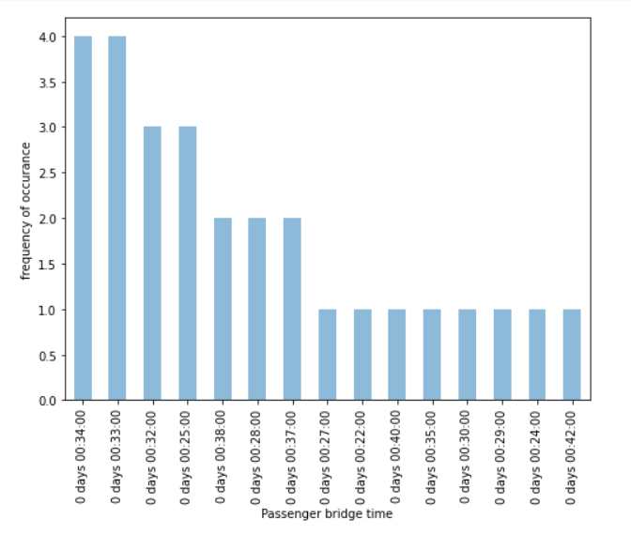FIG6

Insight 5

13 out of 28 aircafts took 32 or lesser minutes which is close to 50% of the dataset. If we consider 33 minutes and ignore the 1 minute of delay then we have 17 out of 28 aircrafts within the ideal mean time.

Critical path 5: reloading of passengers

The mean time for this process is 8 minutes. This process is can be unpredictable because the punctuality of passengers cannot be controlled.

This process also depends on the cleaning process as the passengers can be allowed to enter the aircraft only after the cleaning process is done.

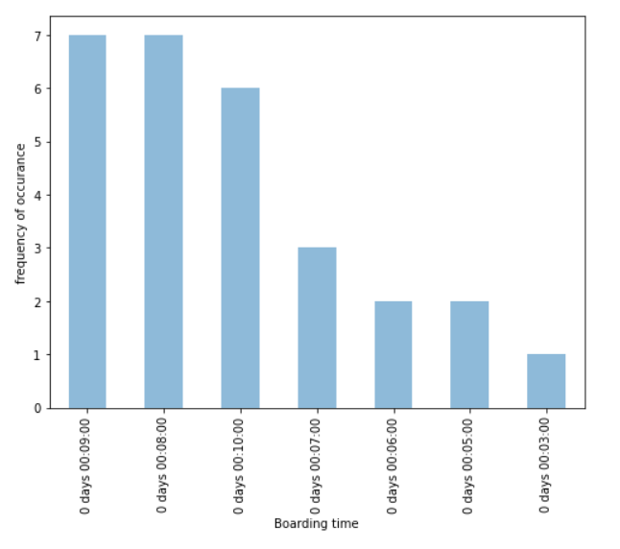FIG7

Insight 6

Boarding is directly corelated to the cleaning process so sooner the cleaning process lesser the delay time for boarding time. 14 aircrafts took 8 to 9 minutes for boarding. 6 took 10 minutes and 8 aircrafts took less than 8 minutes.

Critical path 6 – Restocking of food

The mean time for this process is 6 minutes.

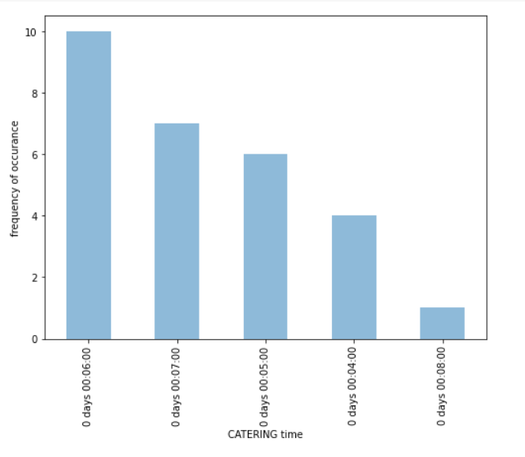FIG7

Insight 7

20 aircrafts take 6 minutes or lesser time for restocking.

To analyse more on critical path we need to find out the delay time of each aircraft. So we take the difference between ‘TAKE OFF’ and ‘EXPECTED TAKE OFF’ columns. FIG8 shows the frequency of distribution of the delayed time.

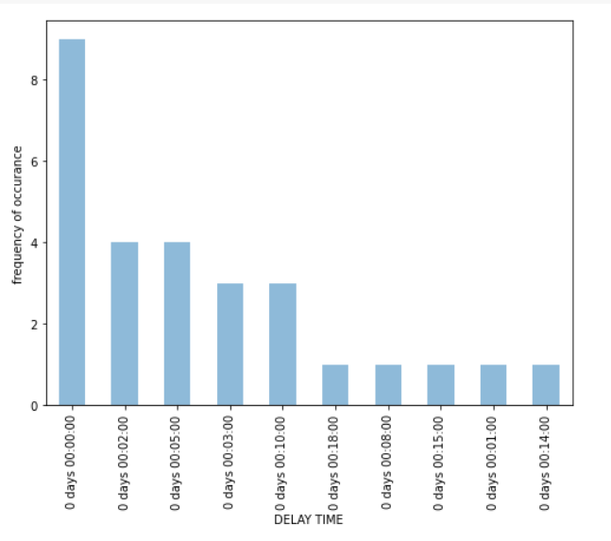FIG8

For this particular analysis we are not considering delays which are 5 or lesser than 5 minutes. The figure shows us that 9 aircrafts are exactly on time 12 aircrafts have a minimum delay of 5 or lesser than 5 minutes which in this case are to be ignored.

7 flights have delays more than 5 minutes and our hypothesis will be tested on these flights.

These 7 flights are shown FIG9.

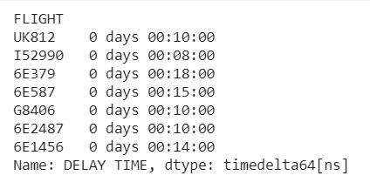FIG9

Before going ahead with the analysis we should find out whether any of the delays are cause by the arrival time.

The difference of ‘SCHEDULED ARRIVAL’ and ‘EXECTED ARRIVAL’ was seen and it was found out that only one of the seven aircrafts had an arrival delay.

This flight was I52990 which had a 10-minute arrival delay.

Moving further to the analysis of the hypothesis, a table was created where each flight had the time consumed for each of its critical path and was compared to the ideal mean time and a difference was take to analyse how much of the delay time is caused by the critical path when compared to the whole delay time. FIG10 shows us the table.

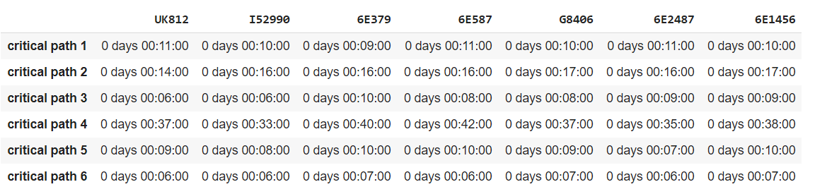FIG10

1. ideal time for critical path 1 is 9 minutes.
2. ideal time for critical path 2 is 16 minutes.
3. ideal time for critical path 3 is 7 minutes.
4. ideal time for critical path 4 is 31 minutes.
5. ideal time for critical path 5 is 8 minutes.
6. ideal time for critical path 6 is 5 minutes.

Now we compare these values and the solution is obtained.

flight UK812 (11-9) + (14-16) + (6-7) + (37-31) + (9-8) + (6- 5) = 7 minutes out of the 10 minutes delay is caused by the critical paths which is 70% of the delay time.

flight I52990 (10-9) + (16-16) + (6-7) + (33- 31) + (8-8) + (6-5) = 3 minutes of the 8 minutes delay is caused by the critical paths which is 37.5% of the delay time.

flight 6E379 (9-9) + (16-16) + (10-7) + (40-31) + (10-8) + (7-5) = 16 out 18 minutes of delay is caused by critical path which is 88%of the delay time.

flight 6E587 (11-9) + (16-16) + (8-7) + (42- 31) + (10-8) + (7-5) = 16 minutes of delay is caused by the critical path but here the delay is only 15 minutes, that means the other processes which arent a part of the critical path have been more effecient and have taken lesser time for their processes than the mean time.

flight G8406 (10-9) + (17-16) + (8-7) + (37-31) + (9-8) + (7-5) = 12 minutes of the delay is caused by the critical path but here the delay is only 10 minutes and the same conclusion is applied as applied for flight 6E587

flight 6E2487 (11-9) + (16-16) + (9-7) + (35-31) + (7-8) + (6-5) = 8 minutes of the 10 minutes delay is caused by the critical paths which is 80% of the delay time.

flight 6E1456 (10-9) + (17-16) + (9-7) + (38 – 33) + (10-8) + (7-5) = 13 minutes out of 14 minutes of delay is caused by critical path which is 92% of the delay time.

if we calculate the percentage of delay caused by the critical paths for each flight

UK812 = 70%

I52990 = 37.5%

6E379 = 88%

6E587 = 100%

G8406 = 100%

6E2487 = 80%

6E1456 = 92%

The mean percentage of these delays is 81%.

REF:[ turnaround analysis code ]

**CONCLUSION:**

The hypothesis is accepted as 81% of the total delay time is caused by the critical paths. The longer the aircraft stays in the ground the more money the airlines looses, hence the reduction of these critical paths will help in the reduction of delays of the aircrafts and when such goals are set it also improves the productivity of the airport operations department.